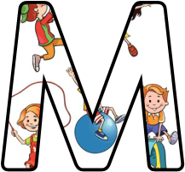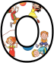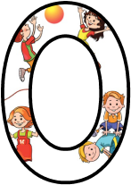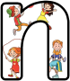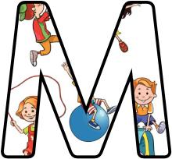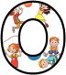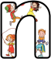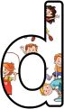

May 2016

Monday Active Homework 03/05/16 (Tuesday)

09/05/16
16/05/16

23/05/16

Junior Infants
8X Reacher Upper (jump in air, touch the ground)
8X Weight Lift (hold bottle of water in 2 hands, lift to chest bending at elbows)
8X Mountain Climbers (hands on ground, bring knees towards body)
8X Hop on one leg

Repeat 3 times

April 2016

Monday Active Homework 04/04/16

11/04/16
18/04/16

25/04/16

Junior Infants

8X March
8X Jumping Jack
8X Heel Touch (kick up heels behind, touch with hands)
8X Hop on one leg

Repeat 3 times

February/March 2016

Monday Active Homework 29/02/16

07/03/16
14/03/16

Junior Infants

8X Shoulder Shrug
8X Trunk Twister (twist from waist, hands on hips)
8X Reacher Upper (jump in air, touch the ground)
8X Hop on one leg

Repeat 3 times

