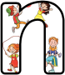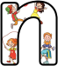

May 2016
Monday Active Homework 02/05/16

09/05/16

16/05/16
23/05/16

30/05/16

8X squats
8X touch your toes keeping your legs as straight as possible!
8X running on the spot trying to lift your knees as high as your hands

Repeat 3 times

